Yêu cầu:
- Sau khi làm xong:
  - Nộp dữ liệu bài thi gồm images, file html, file css lên hệ thống elearning
  - Video nộp tại link google drive (cung cấp sau)
- Định dạng theo yêu cầu:
  - Font chữ: Playfair Display (tại menu và banner); Open Sans - phần còn
  - Size chữ: 20px
  - Màu chữ, màu nền: #07484A, #70908B, #FDFBF8, #E0DFF6; #D9D9D9; #FFFFFF; #6E757E; #F9D9DA; #ADADAD; #C4C4C4; CAF3E5;
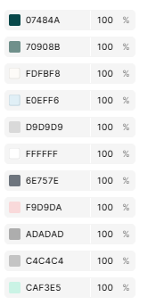
  - Icon font: sử dụng font awersome
    - Link:
<link rel="stylesheet" href="https://cdnjs.cloudflare.com/ajax/libs/font-awesome/6.7.2/css/all.min.css" integrity="sha512-Evv84Mr4kqVGRNSgIGL/F/aIDqQb7xQ2vcrdIwxfjThSH8CSR7PBEakCr51Ck+w+/U6swU2Im1vVX0SVk9ABhg==" crossorigin="anonymous" referrerpolicy="no-referrer" />
    - Danh sách icon:
 <i class="fa-solid fa-circle-user"></i>
 <i class="fa-solid fa-magnifying-glass"></i>
 <i class="fa-solid fa-cart-shopping"></i>
 <i class="fa-regular fa-cart-shopping"></i>
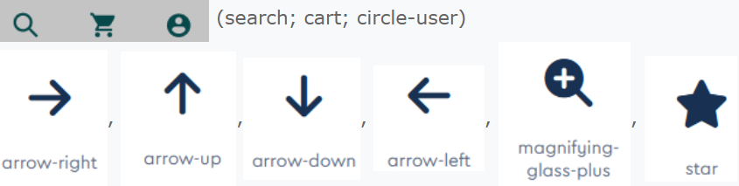<i class="fa-solid fa-arrow-right"></i>
<i class="fa-solid fa-arrow-left"></i>
<i class="fa-solid fa-arrow-up"></i>
<i class="fa-solid fa-arrow-down"></i>
- Nội dung sử dung trong bài thi
- Home, Products, Categories, About, Contact Us
- Exclusive Deals of Furniture Collection
- Explore different categories. Find the best deals.
- Shop Now
Explore by Category
- cột trái: Search; Bedroom, Dinning Room, Meeting Room, Workspace, Living Room, Kitchen, Living Space; All Categories
- cột phải: Bedroom, Explore; Dinning Room, Meeting Room, Workspace, Living Room, Kitchen Room
Popular Products
- Armchair, Light single chair, $145
- Premium Sofa, Light single chair, $145
- Minimal Sofa, Light single chair, $145
- Dining Chair, Light single chair, $145
- Explore all items
Testimonials
Over 15,000 happy customers.
“Lorem ipsum, dolor sit amet consectetur adipisicing elit. Vero tempore voluptates veritatis at quasi cumque porro, libero impedit tempora dicta eveniet iusto voluptate, dicta eveniet iusto voluptate. Error, odio unde?”
Leona Paul, CEO of Floatcom
Copyright ©2025 STUDENT’S NAME. All Rights Reserved

